Assignment 1

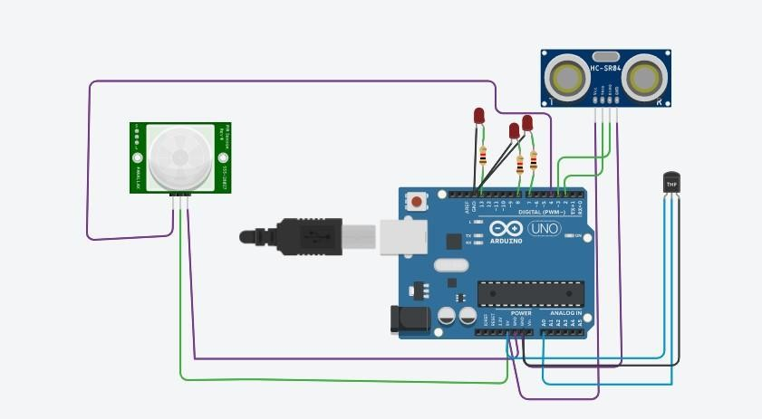

**Code for the circuit:**

int t=2; int e=3; int l=13;

void setup()

{

pinMode(t,OUTPUT); pinMode(8,OUTPUT); pinMode(7,OUTPUT); pinMode(e,INPUT); pinMode(l,OUTPUT); Serial.begin(9600);

}

void loop()

{

digitalWrite(8,0); int a=digitalRead(4);

Serial.println(a); if(a==1)

{

digitalWrite(8,1); Serial.println("Motion detected!!!");

}

delay(1000);

digitalWrite(t,0);

digitalWrite(t,1); delayMicroseconds(10); digitalWrite(t,0);

float dur=pulseIn(e,HIGH); int dis=(dur*0.0343)/2;

analogWrite(l,map(dis,2,320,255,0));

double b=analogRead(A0);

double t=(((b/1024)*5)-0.5)*100; Serial.print("temperature value: "); Serial.println(t);

if(t>100) digitalWrite(7,1); else digitalWrite(7,0);

delay(1000); delay(1000);

}